CHAPTER 4- THE MICROARCHITECTURE LEVEL

Job of microarchitecture level: to implement ISA level above it.

Complexity depends on the ISA type:
- RISC designs have simpler instructions.

An example microarchitecture:
Selected ISA: IJVM
Microarchitecture: A microprogram in ROM, whose job is to fetch, decode and execute IJVM instructions.

Data path:
- 32 bit registers
- 6 control lines for ALU functions:
F0, F1 -> determination of ALU functions
ENA, ENB -> enabling inputs
INVA -> inverting the left input
INC -> add 1 to the result
- 2 data inputs to ALU: A & B
Attached to the left input: H register
Attached to the right input: B bus; can be loaded from any one of 9 registers.
H register can be loaded by choosing the ALU function that passes the right input through to the ALU output. Ex: addition with ENA negated.
- 2 control lines for ALU output:
SLL8: shift left by 8 bits
SHRA1: shift right by 1 bit, leaving the most significant bit unchanged.
- Reading from and writing to the same register on one cycle is possible. How?
The solution is that reading and writing are performed at different times within the cycle.

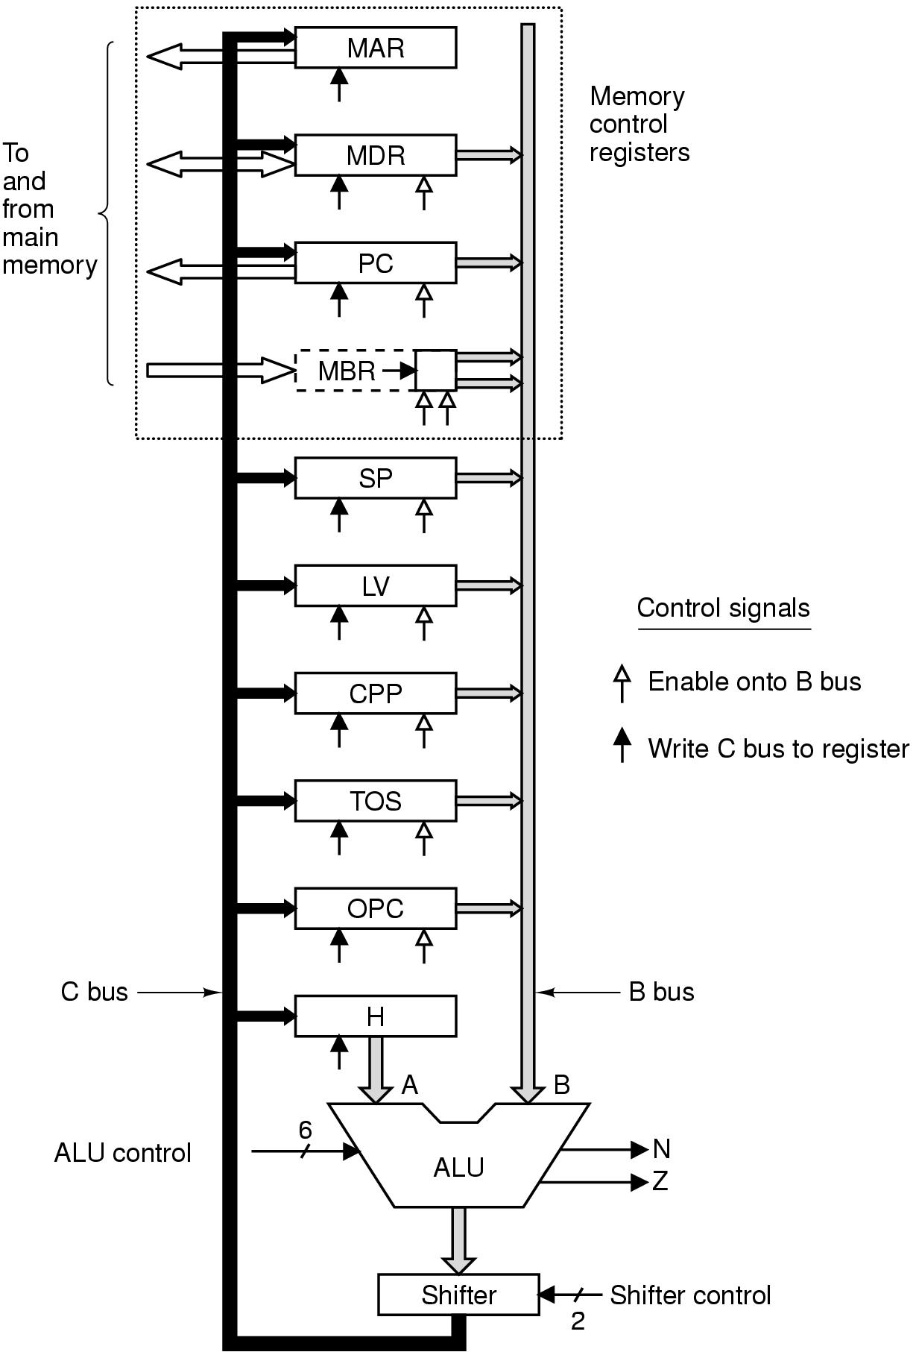

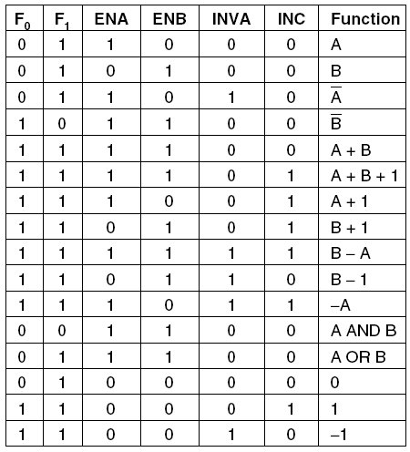

DataPath Timing

A different way to look at the data path cycle is to think of it broken up into implicit subcycles:
- The control lines are setup (Δw).
- The registers are loaded onto B bus (Δx).
- The ALU & shifter operate (Δy).
- The results propogate along the C bus back to the registers (Δz).
At the rising edge of the clock, the results are stored in the
registers.

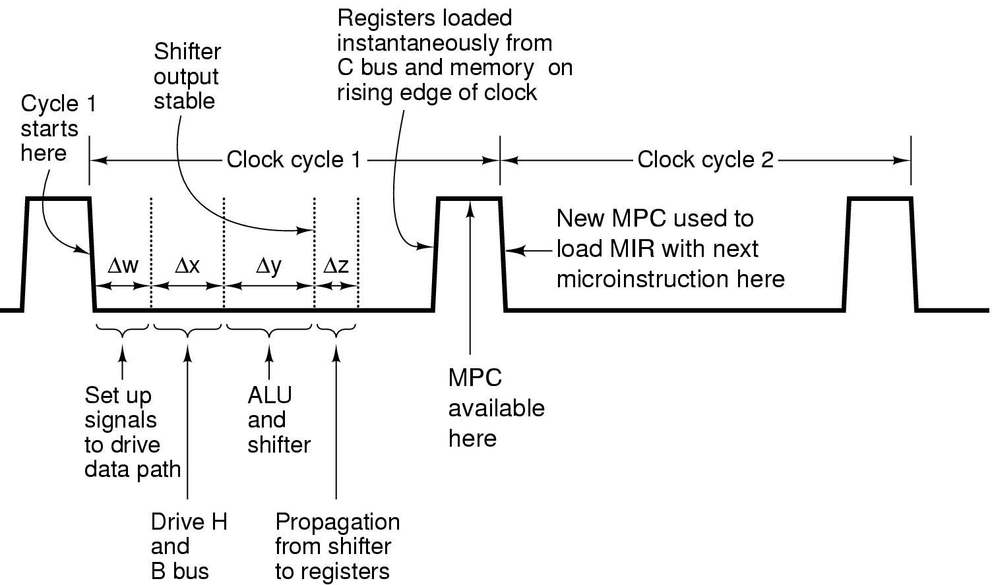
Subcycles are implicit. Subcycle boundaries are determined by the inherent propogation times of the circuits involved.

Memory operation:
32 bit word addressable port: MAR, MDR -> read, write
8 bit byte addressable port: PC, MBR -> read

- Each register is driven by 1 or 2 control lines.
- MAR & H do not have a connection to to the B bus, they don't have an enable signal.
- MBR can't be loaded from C bus. It is loaded from memory. So, it does not have a write signal.
- MAR contains word addresses, PC contain byte addresses.
MAR/MDR combination reads ISA level data words.
PC/MBR combination reads executable ISA level program.
When MAR is placed on to the address lines, its 32 bits do not map onto the 32 address lines directly.
MBR can be gated onto the B bus in one of two ways: signed or unsigned.

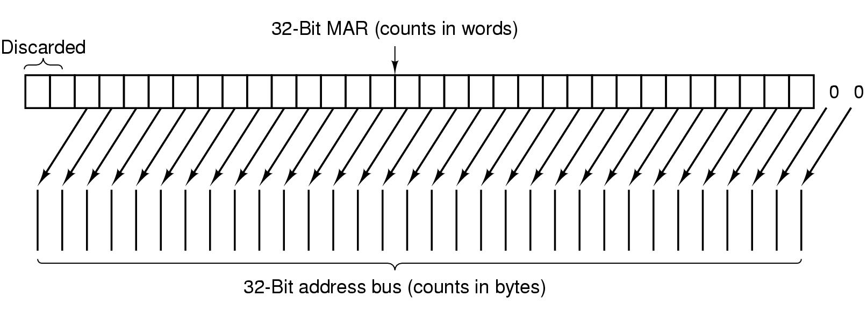
Microinstructions:

29 control signals
- 9 signals for C bus.
- 9 signals for enabling registers onto B bus for ALU inputs
- 8 signals to control ALU and shifter functions
- 2 signals to indicate memory read/write via MAR/MDR.
- 1 signal to indicate memory fetch via PC/MBR.

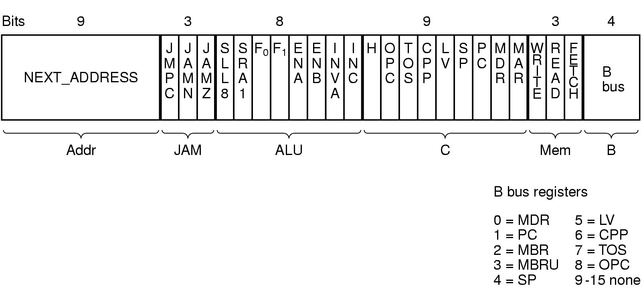
A cycle:
- Gate values out of registers onto the B bus.
- Propogate signals through the ALU and the shifter, drive them onto C bus.
- Write the results in the appropriate registers.

Memory operation:
- started at the end of the data path cycle, after MAR has been loaded.
- Memory data are available at the very end of the following cycle in MBR or MDR and can be used in the cycle after that.
- Initiated at the end of the cycle k, not used in cycle k+1, can be used in cycle k+2.
- Data in MBR/MDR can be read again until new values are loaded in MBR/MDR.
- Decode for C enable: 4+9+8+2+1= 24 signals.
- Another part of control: What is to be done in the next cycle?
Next_address and JAM field.

Microinstruction control: Mic-1

Mic-1 architecture: 1. Data path 2. Control section
Control store:
- A memory for the complete microprogram
- Holds microinstruction sequences, not ISA instructions.
- 512 words of 36 bits.

- Instructions in main memory are eaxecuted in address order (except BRANCHES). Microprograms are flexible. Microinstruction sequences are short. So, each microinstruction explicitly specifies its successor.
- Control store is read only. It needs its own memory address register and memory data register.
MPC: microprogram counter
MIR: microinstruction register

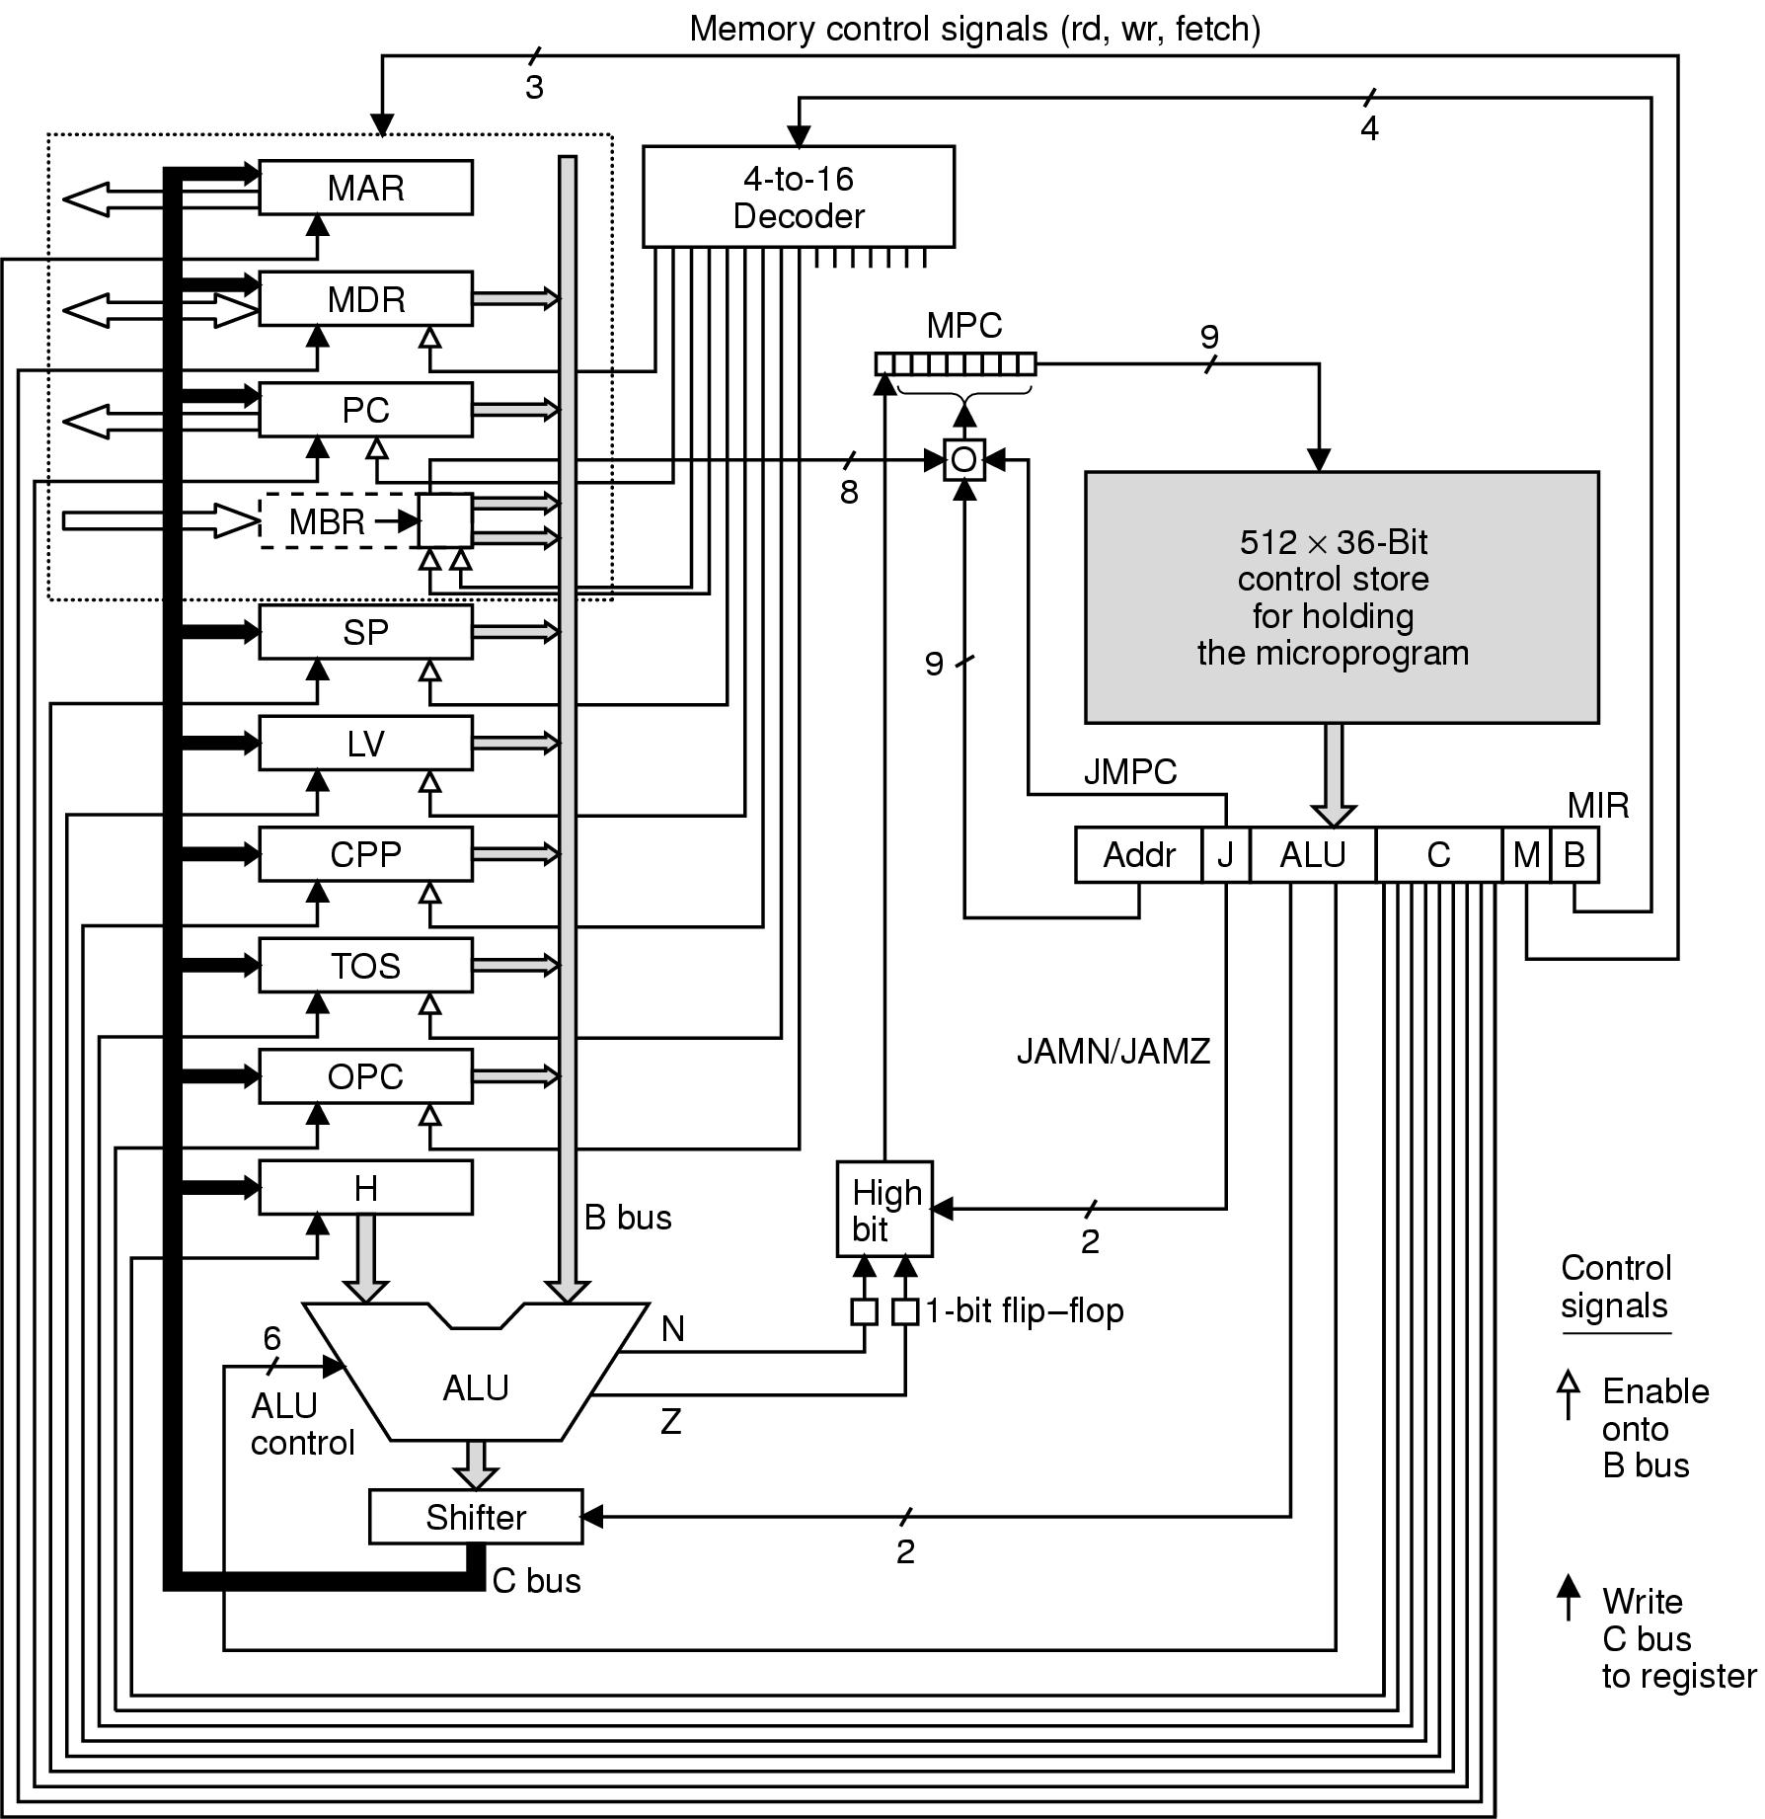

Operation of Mic-1:
- At the start of each clock cycle (the falling adge of the clock), MIR is loaded from the word in the control store pointed by MPC (Δw).
- ALU inputs are stable (Δw+Δx).
- Everything has settled down and ALU, N, Z and shifter outputs are stable. N & Z are saved in a pair of 1 bit flip-flops (+Δy).
- The shifter output has reached the registers via the C bus (+Δz). N and Z flip flops are loaded in this subcycle.

How is the next address calculated?
- 9 bit address from the microinstruction is copied to MPC. While this copying takes place, JAM is inspected. If 000 do nothing.
- If one or more JAM bits are 1, do something!
JAMN: 1 bit N flip-flop is Ored into the highorder bit of MPC.
JAMZ: 1 bit Z flip-flop is Ored into the highorder bit of MPC.
Why do we need these flags? After the rising edge of the clock, B bus is no longer driven, so ALU outputs can no longer be assumed to be correct. Saving the ALU status flags N & Z makes the correct values available and stable for the MPC computation, no matter what is going on ALU.

F= (JAMZ AND Z) OR (JAMN AND N) OR NEXT_ADDRESS.

- JMPC: 8 bit MBR bits are bitwise ORed. Low order 8 bits of the next address field is 0.

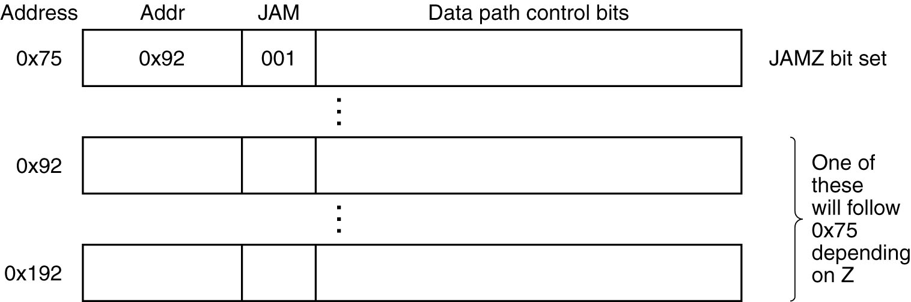

AN EXAMPLE ISA

ISA= MACROARCHITECTURE

Stacks:
Where should the local variables of procedures be kept?
- At absolute memory addresses: Problem during recursion.
- Stack:
LV: stack base
SP: highest word on the stack.

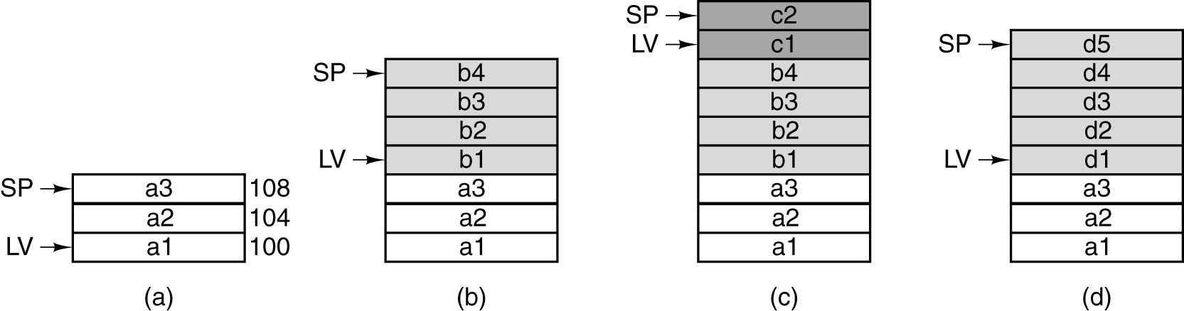

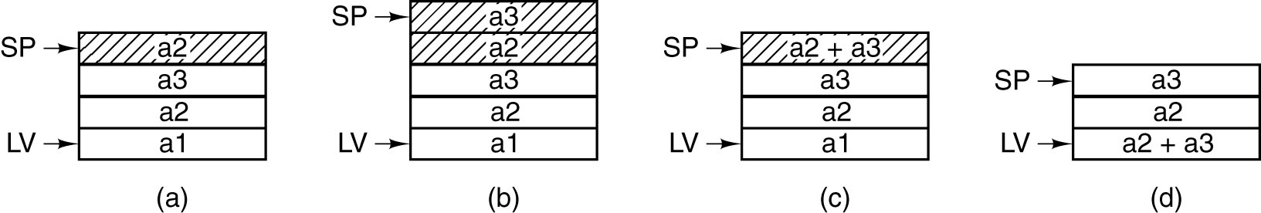

IJVM Memory Model:
- Constant Pool: constants, strings, pointers. Accessed by CPP.
- Local Variable Frame: For each invocaton of a method, an area is allocated for storing variables during the lifetime of the invocation.
LV: a register containing the address of the 1st location in the local variable frame. Parameters passed at the invocation of the method are stored at the beginning of tha local variable frame.
- The operand stack:
SP- a register that contains the address of the top word of the stack.
It is above the local variable frame.
- The method area:
Text segment: region of the memory containing the program- accessed by PC.
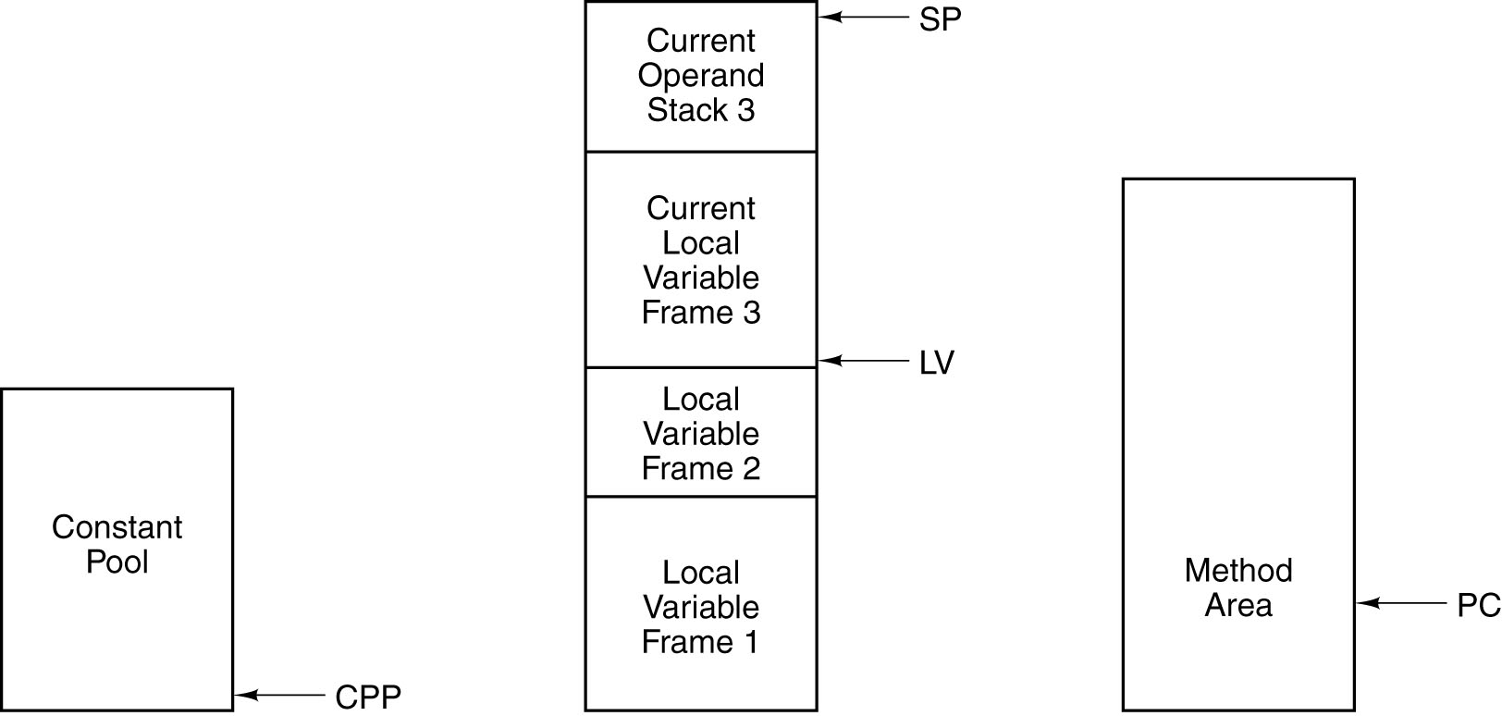

IJVM INSTRUCTION SET:

- Push a word from various sources onto the stack:
LDC_W, ILOAD, BIPUSH
- Pop a word from the stack and store it intothe local variable (ISTORE).
- Arithmetic operations: IADD, ISUB.
- Logical operations: IAND, IOR.
- Branch instructions: GOTO, IFEQ, IFLT, IF_CMPEQ
- SWAP
- INVOKE VIRTUAL and IRETURN

INVOKING A METHOD:
- The caller pushes onto the stack a reference pointer to the object being called (OBJREF).
- The caller pushes the method's parameters onto the stack.
- INVOKEVIRTUAL includes a displacement which indicates the position in the constant pool that contains the start address within the method area for the method being invoked.
- While the method code resides at the location pointed by this pointer, the 1st 4 bytes in the method area contain special data:
The 1st 2 bytes: 16 bit integer: number of parameters for the method area.
2nd 2 bytes: size of the local variable frame for the method.
5th byte: 1st opcode to be executed.

AN EXAMPLE IMPLEMENTATION:
SP=SP+1; rd
MDR=SP
MDR=H+SP
MDR=SP+H
MDR=SP+MDR-> illegal H=H-MDR ->illegal
SP=MDR=SP+1

Mic-1 has two ways of accessing memory:
- Read/writes of 4 byte words: use MAR/MDR and indicated by rd,wr.
- Reads of 1 byte opcodes: PC/MBR, indicated by fetch.

However, the same register may not receive a value from memory and the data path in the same cycle.

MAR=SP; rd
MDR= H

To test a flag: TOS=TOS
To look nicer: Add 2 imaginery registers: N and Z.

Z=TOS;if (Z) goto L1; else goto L2.
For JMPC bit: goto (MBR or value): MBR is ORed into MPC along with the next address.

TOS: Top word of the stack, pointed by SP.
OPC: to save the address of the opcode for a branch instruction.

DESIGN OF THE MICROARCHITECTURE LEVEL

Speed vs. cost:

3 basic approaches for increasing the speed of instructions

- Reduce the number of clock cycles (PATH LENGTH) needed to execute an instruction: use an incrementer register for PC, increase the memory port to 16 bits.
- Simplify the organization such that clock cycle can be smaller: remove B bus decoder: more control storage, more cost
- Overlap the execution of instructions: separate fetch from execution

REDUCING THE EXECUTION PATH LENGTH

- Merge the interpreter loop with the microcode
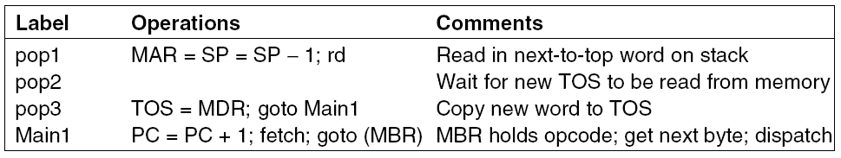
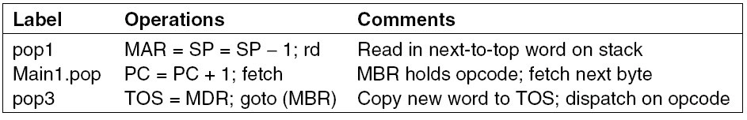

- Use a 3 bus architecture
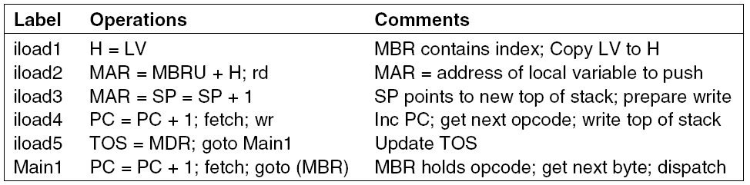
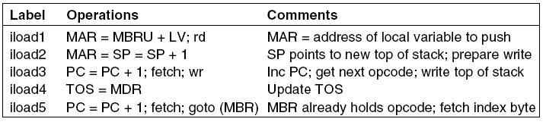

- Use an instruction fetch unit:
For every instruction, the following operations may occur:
- PC is passed through the ALU and incremented.
- PC is used to fetch the next byte in the instruction stream.
- Operands are read from memory.
- Operands are written to memory.
- ALU does the computation and results are stored in registers.

IFU: Instruction fetch unit to separate fetch and execution.
- IFU can interpret each opcode, determining how many additional fields must be fetched and assemble them into a register ready for use by the main execution unit.
- IFU can take advantage of the stream nature of the instructions and make available at all times the next 8 and 16 bit pieces whether or not doing so make any sense.

IFU must monitor the C bus so that whenever the PC is loaded, the new PC value is copied to IMAR (INVOKE_VIRTUAL).
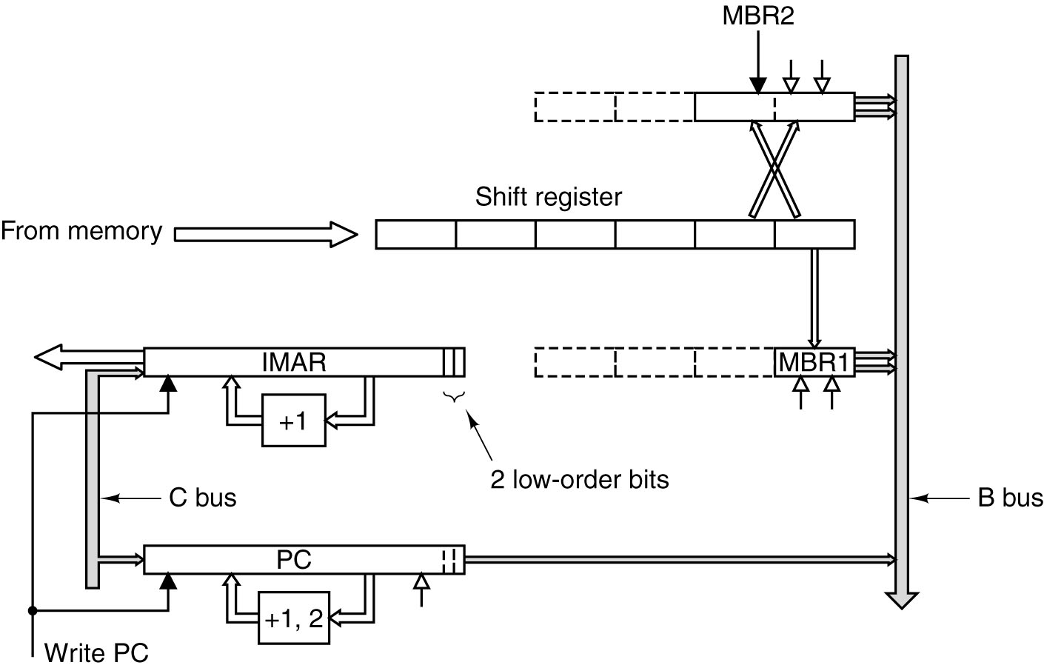

A DESIGN WITH PREFETCHING: MIC-2

-eliminates the main loop
-avoids tying up the ALU incrementing PC.
-reduces path length whenever a 16 bit index or offset is calculated, because it assembles the 16 bit value and supplies it directly to the ALU.

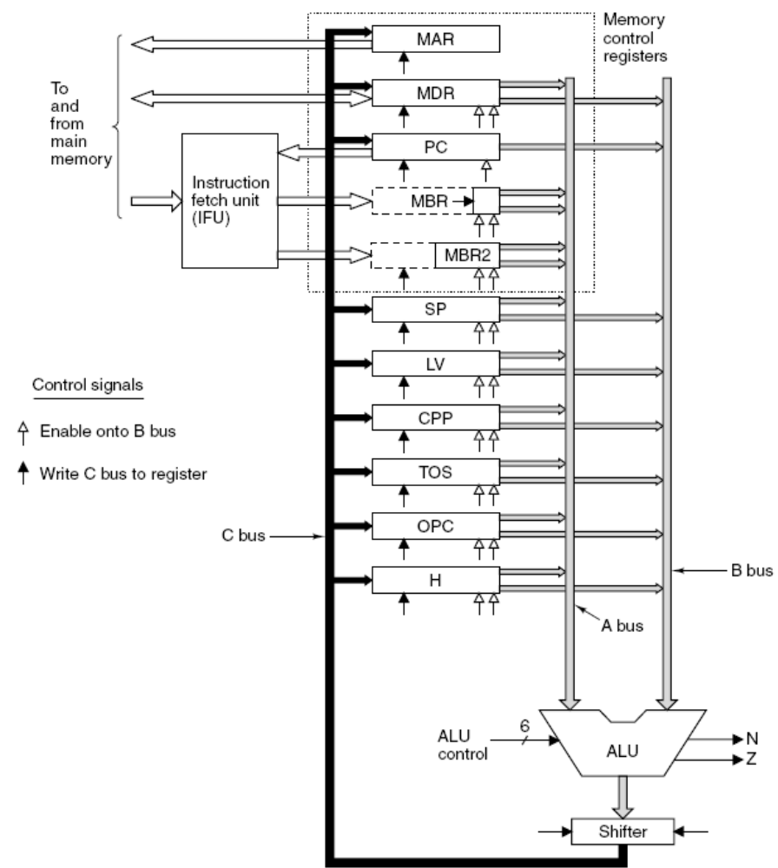

A PIPELINED DESIGN: MIC-3

3 major components to actual data path:
- Time to drive the selected registers onto the A & B buses.
- Time for the ALU and shifter to do their work.
- Time for the results to get back to the registers and be stored.

Use latches to partition the data path into distinct parts that can operate independently of one another.

By latches
- We can speed up the clock because the maximum delay is now shorter (1/3).
- We can use all parts of the data path during every cycle.

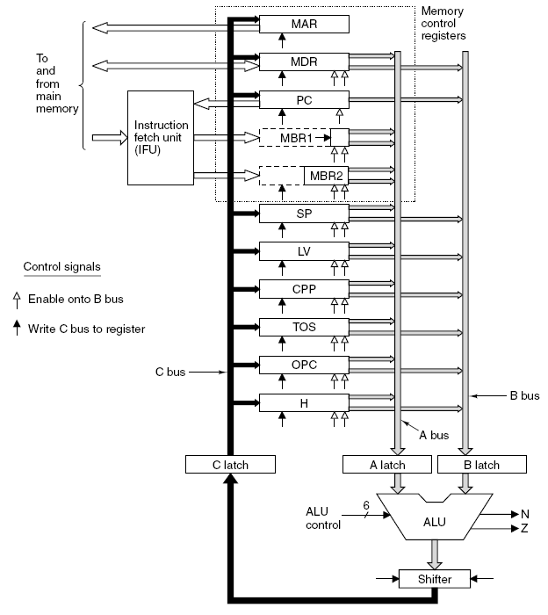

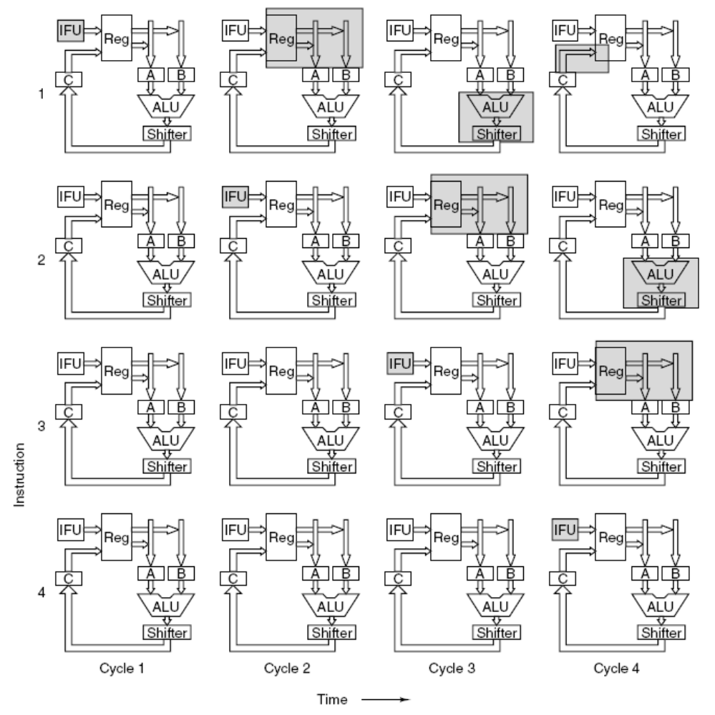
A SEVEN STAGE PIPELINE: MIC-4

A deeply pipelined CPU, which allows the individual steps to be very short and thus the clock frequency high.

Each microinstruction has 2 additional bits: final and goto

The queueing unit works as follows: It receives an index from decoding unit. It then looks up the microops and copies it into queue one by one. When it hits a microop with Final bit=1, it stops. It sends an ACK back to the decoding unit. Decoding unit sends the index of the next instruction.

When it hits a microop with Goto bit=1, it does not send ACK to decoding unit until the branch has been resolved. The machine will stall at this point until the branch has been resolved.

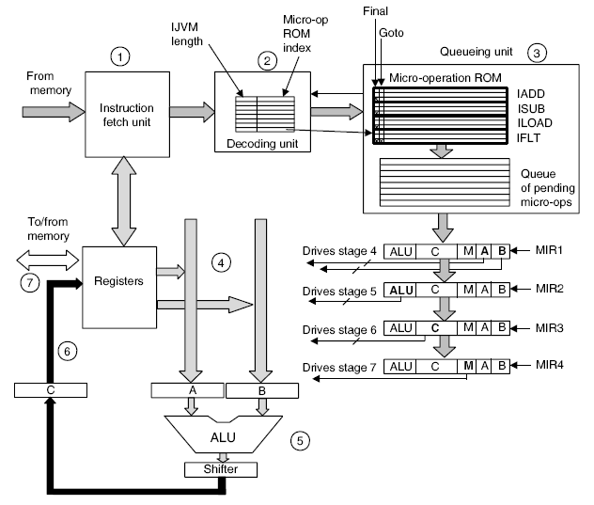

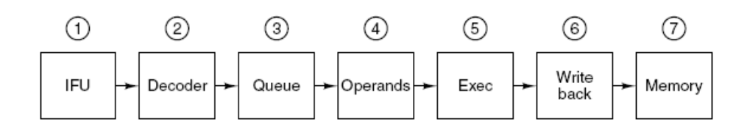

IMPROVING PERFORMANCE

- Caches
- Branch Prediction
- Out-of Order Execution and Register Renaming
- Speculative Execution

- CACHES

Split cache: separate caches for instruction and data
Level 2 cache
Level 3 cache

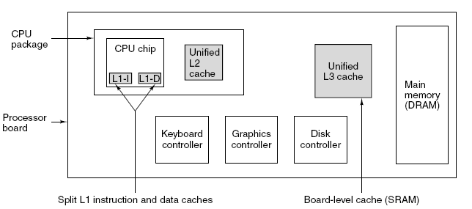

Caches depend on 2 kinds of address locality to achieve their goals:
Spatial locality and temporal locality
Cache line: 4- 64 consecutive bytes

- Direct mapped caches
- Set associative caches

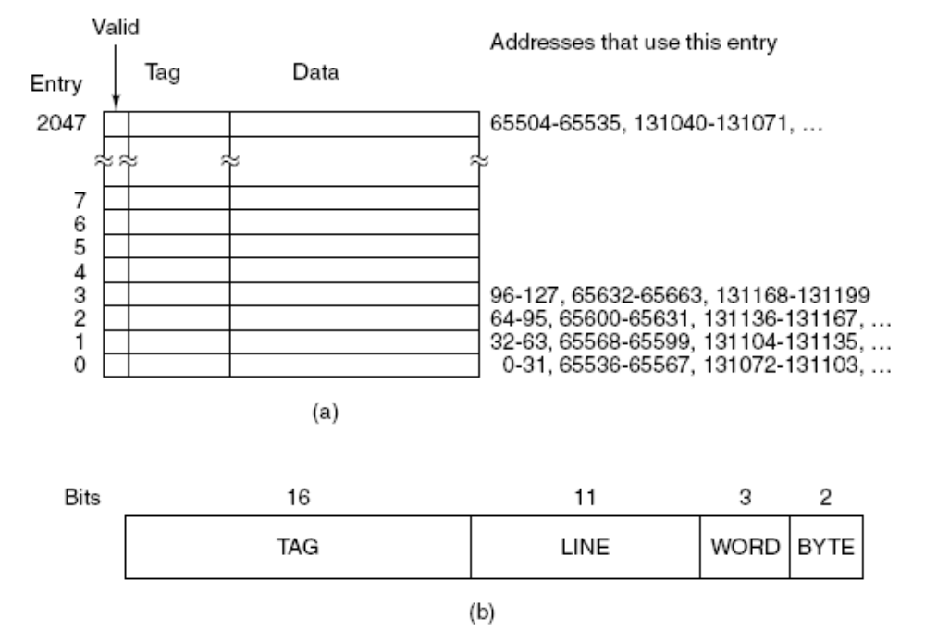

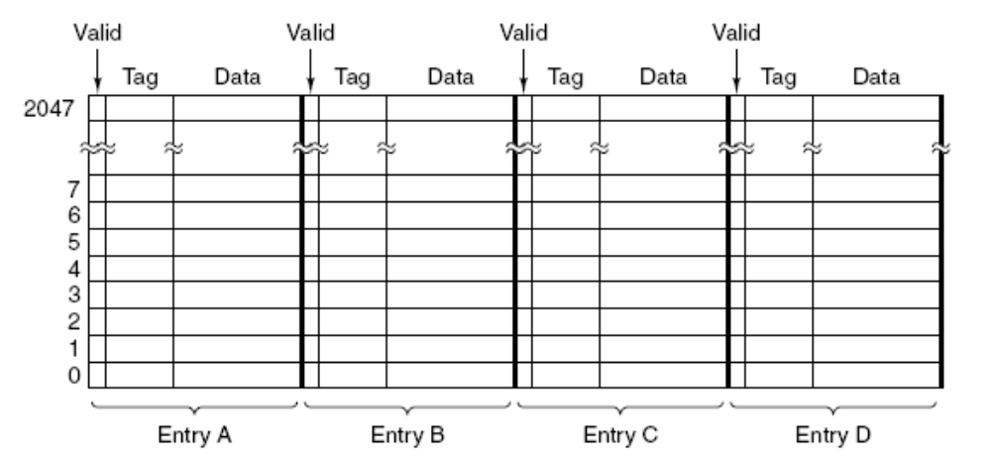

Remove lines from cache according to LRU principle.

Updating a memory location:
1. Immediate updating: write through: simpler, requires more traffic
- Write deferred (write back): update main memory when the cache line is to be removed by LRU.

What if a write occurs to a location that is not currently cached?
- Write allocation: bring data into cache.
- Write memory to directly.
1 wins if there are repeated writes to the same or different words within a cache line.

2.BRANCH PREDICTION

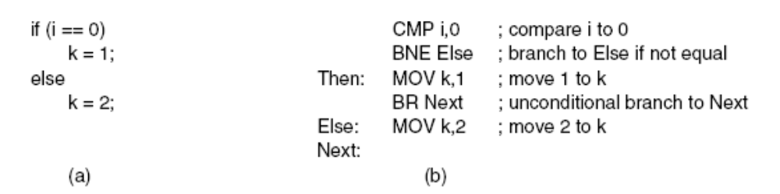

Pipelining works best on linear code; so the fetch unit can just read in consecutive words from memory and send them off to the decode unit in advance of their being needed. However, programs are not linear code segment. Fetch unit has to decide where to fetch from next before it knows what kind of instruction it just got.

- Unconditional branch: delay slots
- Conditional branch: delay slots + stalling until learning where to read from.

A solution: prediction: Assume all backward conditional branches will be taken (loops) and all forward ones (error conditions) will not be taken.

If prediction is correct, execution proceeds.
If not, undo instructions that have been executed.
- Allow instructions fetched after a predicted conditional branch to execute until they try to change the machine state.
- Record the value of any register about to be overwritten so the machine can be rolled back to the state it had at the time of the mispredicted branch.
Both solutions are complex.

- Dynamic prediction: CPU maintains a history table, in which it logs conditional branches as they occur, so they can be looked up when they occur again. There are several ways to organize the history table.
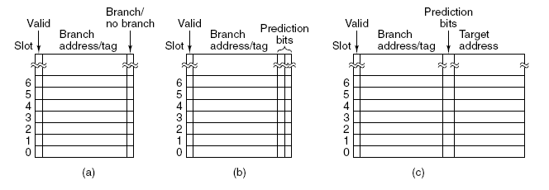
- Static prediction:
-get help from compiler
-run the program actually and capture its branching behavior.

- Out-of-order Execution and Register Renaming
- If any operand is being written, do not issue read (RAW dependence)
- If the result register is being read, do not issue write (WAR dependence)
- If the result register is being written, do not issue write(WAW dependence)
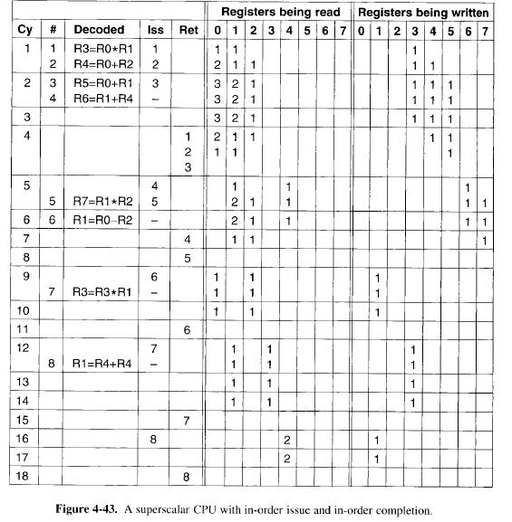

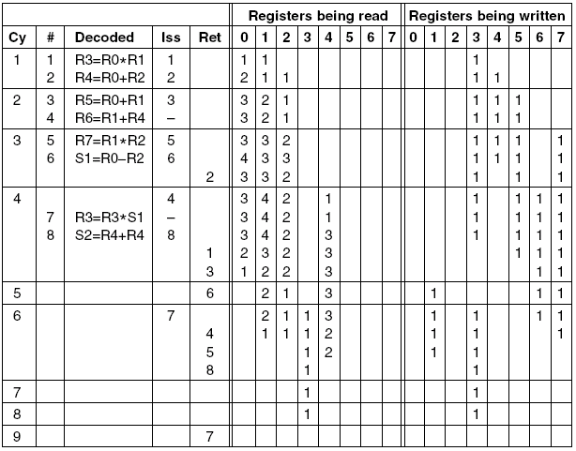

- Speculative Execution

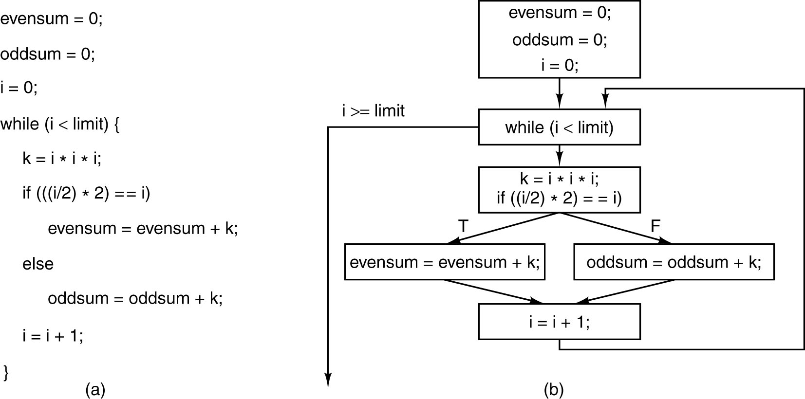

-Executing code before it is known if it is even going to be needed.
-requires support from the compiler and the hardware.
-only scratch registers are modified, so there is no problem if the code ultimately is not needed. If it is needed, the scratch registers are copied to the true destination register.
-Performance improvement with hositing: moving code upward over a brnch
-What happens if a speculatively executed instruction causes an exception?
One solution: have a special SPECULATIVE_LOAD instruction that tries to fetch the word from the cache, but if it is not there just gives up. If the code is there when it is actually needed it can be used, but if it is not, the hardware must go out and get it.
-if (x>0) z=y/x.
Solution: have special versions of instructions that might cause exceptions. A poison bit is added to each register. When a special speculative instruction fails, instead of causing a trap, it sets the poison bit. If that register is later touched by a regular instruction, the trap occurs then. However, if the result is never used, the poison bit is eventually cleared and no harm is done.

EXAMPLES OF THE MICROARCHITECTURE LEVEL

- Core i7 CPU

On the outside
- A traditional CISC machine
- A huge and unwieldly instruction set supporting 8,16,32 bit integer operations as well as 32 and 64 bit floating point operations
- 8 visible registers
- 1-17 bytes length instructions
Inside
- Contains a modern, lean-and-mean, deeply pipelined RISC core
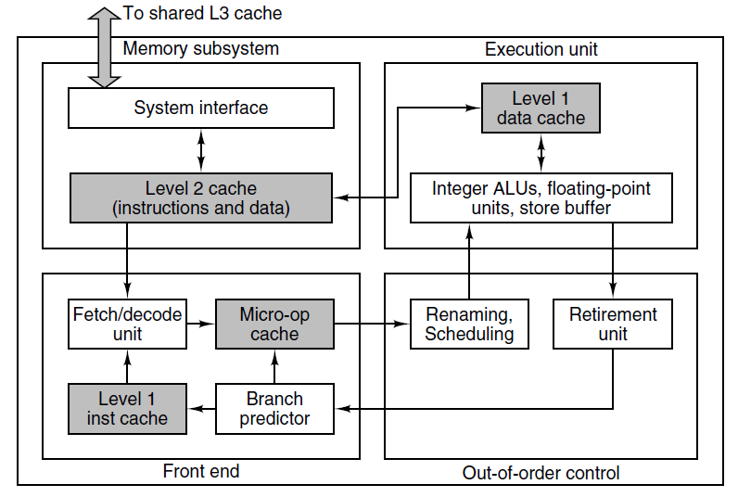

- Sandy Bridge microarchitecture
  - Significant refinement of the previous generation Intel microarchitectures
  - 4 major subsections: Memory Subsystem, the front end, out of order control and execution units
  - Memory Subsystem:
    - Each processor in the Core i7 contains a memory subsystem with a unified L2 cache as well as the logic for accessing the L3 cache.
    - L3 cache is shared by all processors.
    - L2 cache: 256 Kb, 8 way associative cache based on 64 byte cache lines
    - L3 cache: 1 MB-20 MB, 12 way associative cache with 64 byte cache lines
    - Associated with L1 cache are 2 prefetch units:
One of them prefetches the next memory block when it detects that a sequential stream of memory is being fetched.
The other is based on stride-oriented prefetching.

  - Front end
    - Fetches instructions from the momory subsystem and decodes them into RISC like microoperations and stores them in two instruction storrage caches.
    - All instructions fetched are placed into L1 instruction cache ( 32 KB, 8 way associative)
    - Instructions fetched from the L1 cache enter decoders and they are broken down into a sequence of RISC-like micro-ops. The decoded microinstructions are fed into micro-op cache (L0 cache).
    - L0 cache reduces front end power consumption. The remainder of the front end sleeps in an unclocked power mode 80% of the time. Instructions corresponding to less than 4 microinstructions are not decoded after encountered once. The corresponding microinstructions are saved in the Micro-op cache. This is the RISC core of Intel I7.
    - Branch prediction: top secret
      - Scheduler
    - Out of order issue and execution, register renaming
    - in order retirement due to precise interrupts
- Execution Unit
    - Multiple execution units get data from L1 data cache.

The Sandy Bridge Pipeline:
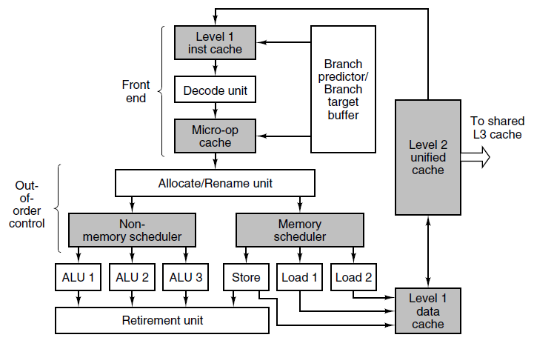

The front end fetches instructions from memory,
- Decodes them into micro-ops for storage in the micro-op cache.
- Micro-op cache holds 1.5K micro ops. It gives comparable performance to a 6KB conventional L0 cache.
- Holds groups of 6 micro-ops in a single trace line.
- If the decode unit hits a conditional branch, it refers to a dynamic branch predictor. If the branch instruction is not in the table, static prediction is used. For loops, a backward branch is assumed to be taken (high accuracy). A forward branch is assumed to be part of an if statement and is assumed not to be taken (lower accuracy).
- Branch target Buffer (BTB): determines the target adress for a taken branch.

Out-of-order control unit is fed from the micro-op cache.
- As each micro-op comes, upto 4 per cycle, the allocation/renaming units logs it in a 168-entry table called the Reorder Buffer (ROB). If all resources are available a micro op is enqueued for execution in one of the execution units. Otherwise, it is delayed. The goal is to keep all the functional units as busy as possible.
- Seperate queues for memory and nonmemory operations.
- 154 instructions can be in flight at any instant.
- 64 loads from memory, 36 stores to memory
- 160 scratch registers for register renaming
- The scheduler queues send micro-ops into 6 functional units when they are ready to execute.
- A 3GHZ core i7 can issue upto 18 billion operations per second in theory.
- The 3 integer ALUs are not identical.
  - ALU 1: all arithmetic and logical operations, multiplies and divides.
  - ALU 2: only arithmetic and logical operations
  - ALU 3: arithmetic and logical operations and resolves branches.

- The 2 floating point ALUs are not identical. One is for additions, subtractions and moves. The other is for all floating point arithmetics including multiplies.
- The ALU and floating point units are fed by a pair of 128 entry register files.
- AVX- Advanced Vector Extensions for 128 bit data paralel vector operations.
- L1 data cache:
  - 8 way associative, write back
  - 2 read and 1 write operation at the same time with banking, which splits the cache into separate subcaches
  - Upto 10 requests from L1 cache to the L2 cache can be in progress at the same time.

Retirement unit has the job of retiring instructions.
- in order completion for precise interrupts.
- Store to load forwarding: If a store instruction is retired before previous instructions, data is not written to L1 cache, but forwarded into a 36 entry pending store buffer. Any subsequent loads retrieve data from this buffer.

Summary:
GOAL: to execute old Pentium instruction set on a modern, highly pipelined RISC core.
- Breaks Pentium instructions into micro-ops,
- caches them,
- feeds them to the pipeline 4 at a time for execution on a set of ALUs capable of executing upto 6 micro-ops per cycle under optimal conditions.
- Micro-ops are executed out of order but retired in order and the results are stored into the L1 and L2 caches in order.

- ULTRA SPARC3

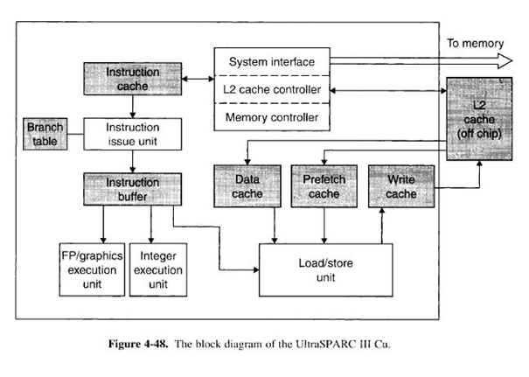
- Implementation of the Version 9 SPARC architecture
- CU- copper wiring as opposed to the aluminum wiring in its predecessor. Cu has lower resistance than aluminum, which allows for faster and thinner wires.
- 64 bit machine
- 64 bit registers and 64 bit data path
- For backward compatibility to Version 8 SPARC, it can also handle 32 bit operands
- 128 bits wide memory bus
- RISC architecture: no need to break instructions into microoperations
- Microarchitecture is simple than NetBurst due to its simple ISA.
- L1 data cache: 8KB-16KB
- L1 instruction cache: 32 KB, 4way associative, 32 byte cache line, 8 K instructions
- Instruction issue unit prepares 4 inst. per clock cycle
- A branch table with 16 K entries
- 16-instruction buffer that smoothes out the flow into the pipelines.
- Integer execution unit:2 ALUs, a short pipeline for branches, ISA and scratch registers
- Floating point with 3 ALUs for addition/subtraction, multiplication and division.+graphical instruction
- Data cache: 64 KB, 4way associative L1 cache,32 byte line size
- 2KB prefetch cache: compiler fetches data words before they are needed.
- 2 KB Write cache: combine results to write into L2 cache
- Controllers for memory Access:
- System Interface: interface with memory over a 128 bit wide bus.
- L2 cache controller:
L2 cache : 1 MB (64 byte cache line) , 4 MB, 8 MB (512 byte cache line)
UtraSPparc Level 2 cache has a higher hit rate than Pentium, but slower Access
- Memory controller:
supports virtual memory with page sizes of 8 Kb, 64 KB, 512 KB and 4 MB. Translation Lookaside Buffers for speed reasons.
- Sparc III Pipeline
A – Adress generation
P – Preliminary fetch: fetsches up to 4 instructions from L1 I-cache
F- completes fetching
B- Branch Target- decodes the fetched instruction
I- Instruction group formation: groups the incoming instructions depending on which of the 6 functional units they use: 2 integer,
2 Floating point ALUs, branch pipeline, Load/store, etc..
J (Instruction grouping) removes instructions from the instruction queue and prepares to dispatch them. Up to 4 instructions can be moved to R stage: 2 int, 1 fp, 1 load/store
R- look up the required register, stall if a suitable one is not found, consistency checking
E- execution of integer ops., load/store and special inst. initiated,
fetching of fp.ops, conditional branches
C- cache: Access to L1 cache completes. Load instructions that read memory deliver their results here.
M- Miss: Data needed but not found in L1 cache is requested from L2 cache , floating point reads
W-write: results are written to the register file
X (extend) FP and graphics instructions complete, store to load forwarding
T (trap)- FPE and integer traps detected, interrupt processing…
D- commitment state (retirement in Pentium), write back to L2 by passing L1-> for Ultrasparc multiprocessors

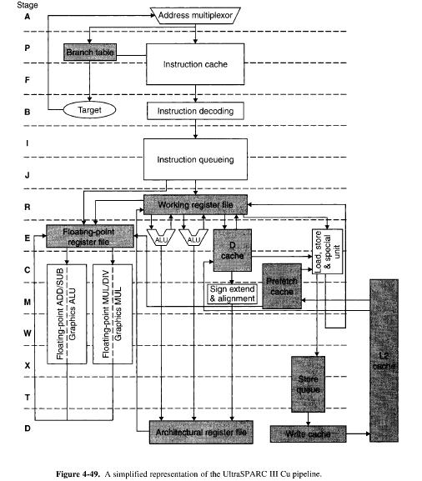
- OMAP4430 CPU
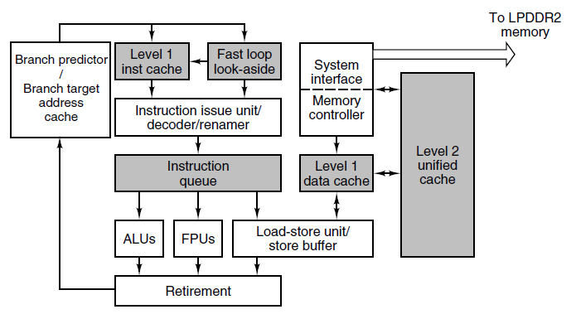

- 32 bit RISC machine with 32 bit registers and a 32 bit data path.
- Execute simple instructions but, in recent years, more complex multimedia and graphics instructions have been added requiring special hardware facilities for their execution.
- Since ISA is simpler, microarchitecture is simpler than Sandy Bridge.
- Both employ cache system. Core i7 has a 3 level cache. Cortex A9 has 2 levels of cache. Last level cache of Cortex A9 (L2 cache) is only 1 MB. Last level cache of Core i7 (L3 cache) is up to 20 MB.
- Level 1 instruction cache: 32 KB, 4 way associative, 32 byte cache lines. Instructions are 4 bytes → 8K instructions
- Instruction issue unit prepares upto 4 instructions per cycle.
- Branch predictor with 4K entries
- Fast loop look-aside cache for small non-nested loops: speeds up instruction fetch and reduces power consumption.
- Decoder determines which resources and inputs are needed by the instruction.
- Renaming and out of order execution
- Multiple functional units
- Additional functional units: ARM supports a compute engine for floating point computation (VFP) and integer SIMD vector computation called NEON.
- Load/store unit:
  - Data cache:
    - 32 KB 4 way associative
    - Store buffer for store to load forwarding
  - System Interface:
    - to access memory over LPDDR2 bus
    - 4GB external RAM can be supported.
  - Memory controller:
    - conversion of 32 bit virtual addresses to 32 bit physical addresses.
    - 2 TLBs (instruction and data) to speed up paging

OMAP4430’a Cortex A9 pipeline:

- 11 stage pipeline
- Conditional branches are resolved in Ex1 stage. In the event of a misprediction, a signal is sent to Fe1 stage and the pipeline is voided.
- 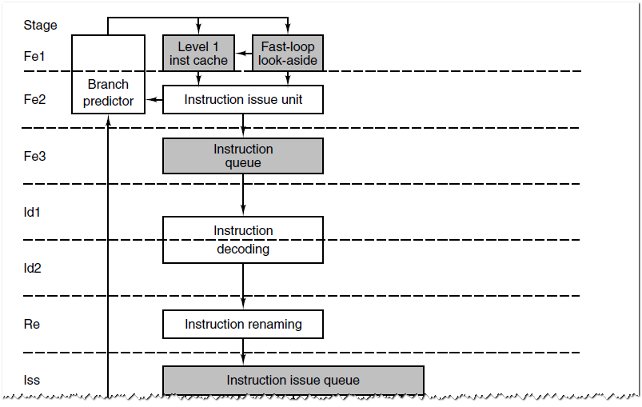

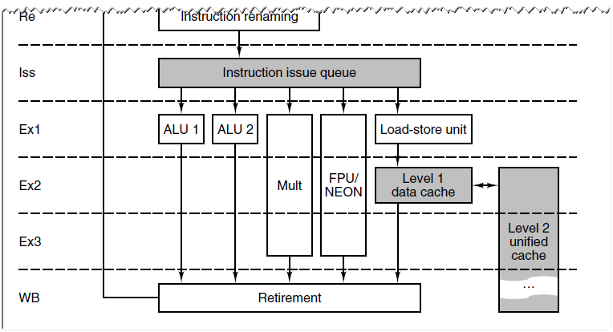

- ATmega168 Microcontroller

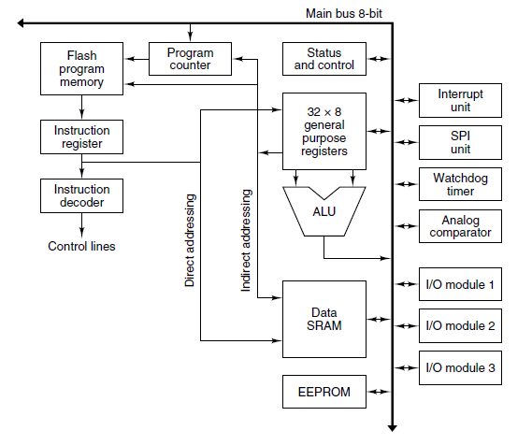

- Simpler than Core i7 and OMAP4430.
- The heart of the ATmega168: 8-bit main bus: everything is attached to it.
- Multiple memories for data and instruction:
  - Up to 16 MB instruction address space
  - Up to 64 KB of data memory
  - 1KB EEPROM storage where programs can write variables that need to survive a power outage.
- Support for real time applications:
  - interrupt controller, Serial port interface (SPI), timers
- 3 8 bit digital I/O ports: control up yo 24 external buttons, lights, sensors, actuators and so on.
- Synchronous processor:
  - Instructions take 1 cycle: 2 operands are read from the register file, run through the ALU and results are stored back into a register.
  - Pipeline with 2 stages: fetch and execute
  - inorder execution

  - COMPARISON of MIC-4, Core I7, SPARC, OMAP4430 and ATMEGA168

Core i7: CISC
OMAP4430, SPARC : RISC
ATmega168: a simple 8 bit processor for embedded applications
The heart of each of them is a set of registers and one or more ALUs that perform simple arithmetic and Boolean operations on register operands.

All have fairly similar execution units: accept microop. with an opcode, 2 source registers and a destination register.
Both of them can execute 1 microop in each cycle.
Both of them have deep pipelines, branch prediction and split I and D caches.
The similarity is due to being the most effective design of the current technology.

The main difference between Core i7 and OMAP4430/SPARC is how they get from their ISA instruction set to the execution unit. Core i7 has to break up its CISC instructions into 3 register format. This is not needed in OMAP4430 and SPARC.

MIC-4 is most like the Core i7
- CISC instructions are divided into simpler instructions
- Microops are deposited in a queue.
- MIC4: strict in order issue, in order execute, in order retire design
- Core i7: out of order execution, in order retire

MIC 4 and OMAP4430/SPARC are not comparable.

In contrast to Core i7, SPARC and OMAP4430, the ATmega168 is a simple machine indeed. It is more RISC-like than CISC like because most of its simple instructions can be executed in one clock cycle. No pipelining, no caching, in order issue, execute & retire. In its simplicty, it is much akin to the MIC-1.

